Flow cytometric analysis of cell cycle with propidium iodide DNA staining

Introduction to flow cytometric analysis
Cell cycle analysis by quantitation of DNA content was one of the earliest applications of flow cytometry.
The DNA of mammalian, yeast, plant or bacterial cells can be stained by a variety of DNA binding dyes. The premise of these dyes is that they are stoichiometric, i.e. they bind in proportion to the amount of DNA present in the cell.
In this way cells that are in S phase will have more DNA than cells in G1. They will take up proportionally more dye and will fluoresce more brightly until they have doubled their DNA content. The cells in G2 will be approximately twice as bright as cells in G1.
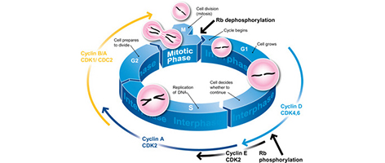

DNA-binding dyes include propidium iodide (PI), 7-aminoactinomycin-D (7-AAD), Hoechst 33342, 33258 and S769121, TO-PRO-3, 4’6’-diamidino-2-phenylindole (DAPI), DRAQ5™ and DRAQ7™.
In most cases, cells must be fixed or permeabilized to allow entry of the dye which is otherwise actively pumped out by living cells. For fixation, alcohol or aldehyde are commonly used. Alcohol is a dehydrating fixative which also permeabilizes. This will allow easy access of the dye to the DNA and gives good profiles (low coefficient of variation, CV). The disadvantage is that it is often incompatible with fluorescent proteins and some surface markers.
If fluorescent proteins or surface markers need to be examined simultaneously, use of an aldehyde (cross-linking) fixative, usually paraformaldehyde is more appropriate. This may lead to poorer quality profiles (higher CVs) but will allow simultaneous detection of other fluorochromes and membrane-bound proteins. However, paraformaldehyde will usually not permeabilize the cell membrane, and so further sample processing is required.
With fixed cells, samples may be accumulated, stained and analyzed at the conclusion of an experiment. Alcohol-fixed cells are stable for several weeks at 4°C. Aldehyde fixed cells are stable for 2 to 3 days.
An alternative method to allow the DNA dye into the cells is to permeabilize them with a detergent. This can be Triton X-100 (0.1%) or NP40 (0.1%). Saponin is not a recommended permeabilizing reagent for DNA analysis as it does not permeabilize the nuclear membrane well. Permeabilized cells cannot be stored for as long as fixed ones and should be processed within hours.
It is also usually necessary to combine a fixation (paraformaldehyde) and permeabilization (Triton X-100) for the intracellular staining. Other methods are also available, e.g. use of citrate buffers (in combination with detergent), although these are not so widespread. There are also some dyes that will enter live cells and quantitatively bind to DNA, these include Hoechst 33342, DRAQ5™ (ab108410) and the DyeCycle dyes.
The method used will depend on the experiment and the information required. In this protocol, PI is used to label DNA content.

Reagents
- 70% Ethanol
- Propidium iodide (stock solution 50 µg/ml)
- Ribonuclease I (stock 100 mg/ml)

Method
- Harvest the cells in the appropriate manner and wash in PBS.
- Fix in cold 70% ethanol. Add drop wise to the pellet while vortexing. This should ensure fixation of all cells and minimize clumping.
- Fix for 30 min at 4°C.
- Wash 2 X in PBS. Spin at 850 g in a centrifuge and be careful to avoid cell loss when discarding the supernatant especially after spinning out of ethanol.
- Treat the cells with ribonuclease. Add 50 µl of a 100 µg/ml sock of RNase. This will ensure only DNA, not RNA, is stained.
- Add 200 µl PI (from 50 µg/ml stock solution).

Analysis of results
- Measure the forward scatter (FS) and side scatter (SS) to identify single cells.
- Pulse processing is used to exclude cell doublets from the analysis. This can be achieved either by using pulse area vs. pulse width or pulse area vs. pulse height depending on the type of cytometer.
- PI has a maximum emission of 605 nm so can be measured with a suitable bandpass filter.

Expected results
While running the cytometer, the following plots should be displayed:
Forward and side scatter to identify the cells
Pulse shape analysis to identify clumps and doublets (this can be pulse area vs. pulse width or pulse area vs. pulse height depending on cytometer)
Forward scatter vs. PI signal; PI histogram.
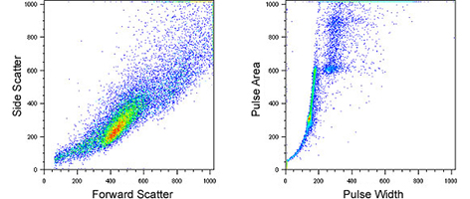

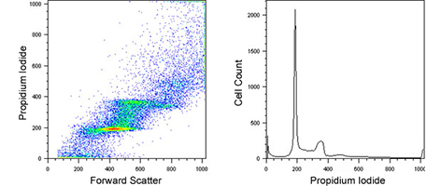
For analysis, first gate on the single cell population using pulse width vs. pulse area. Then apply this gate to the scatter plot and gate out obvious debris. Combine the gates and apply to the PI histogram plot.
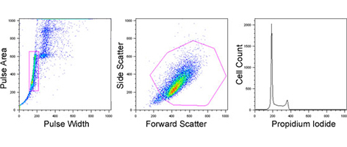
There are two ways to quantitate the percentage of cells in each cell cycle phase:
- By using markers set within the analysis program.
- By using an algorithm which will attempt to fit Gaussian curves to each phase. This is available with some flow cytometry software and is more objective than setting markers by eye.
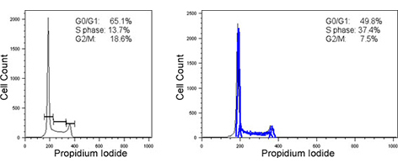

Troubleshooting and tips
- Cells should be kept as concentrated as possible to allow the lowest sample pressure differential to be used. This will ensure that the core sample stream is as narrow as possible and give optimal CVs. The CV, or coefficient of variation, is a measure of spread of the data and is defined as the standard deviation (sd) divided by the mean (m) expressed as a percentage (sd/m x 100).
- 70% ethanol should not be made with PBS as this causes protein precipitation on fixation. Use 70 parts absolute ethanol to 30 parts distilled water.
- Single parameter DNA analysis will not yield any kinetic information, nor will it be able to distinguish between cells in very early or late S phase from cells in G1 and G2 phase respectively. Nor can we distinguish between G2 and Mitotic phase cells. For this information, a bromodeoxyuridine (BrdU) technique should be used or you can combine DNA analysis with a cell cycle phase-specific marker (e.g. phospho H3 for mitosis).

